Duckling cake bunny chick catkin
hen easter egg lamb spring basket

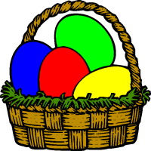


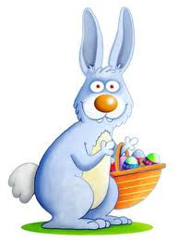
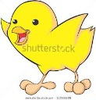

___________________ ___________________ ___________________

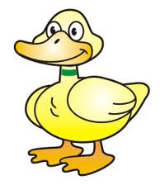
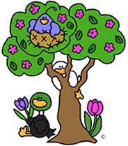
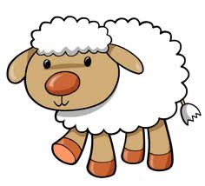
___________________ ___________________ ___________________

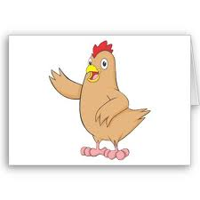
___________________ ___________________ ___________________
___________________
resurrection easter dead coming to life
Christian holiday
Maundy Thursday Holy Saturday Good Friday Easter Sunday

- .Holy Week starts with________________________, continue with ______________________, ________________________ and ends _______________________ in with the ________________________ of Jesus
- ____________________ is the most common ________________________
- We celebrate the ________________________ and ________________________ of Jesus.

