COMPLETE
Win lose physical individually groups

- Sport is a form of _________________ activity.
- Sport can be practice __________________ or in ___________________.
- When practicing sports children learn to ___________ and _____________.
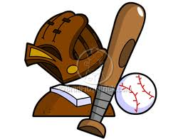
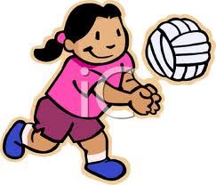
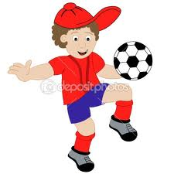
CIRCLE THE CORRECT SPORT
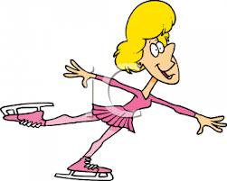

volleyball tennis basketball baseball
football skating football boxing
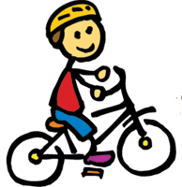
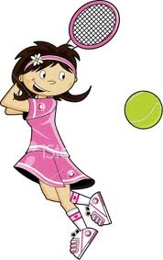
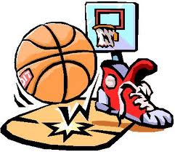
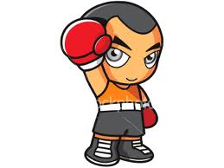

cycling tennis basketball swimming
boxing hockey volleyball cycling
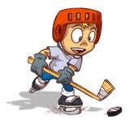
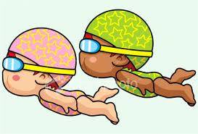

skating hockey
swimming tennis

