cute clumsy spring milk worms

- Baby animals are often born in the__________.
- Parents provide _________or _____________to feed their babies.
- Baby animals are __________and make ___________ movements.

MATCH
- _________ foal
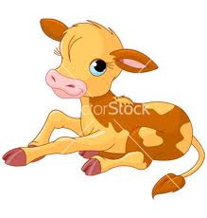
- _________ duckling
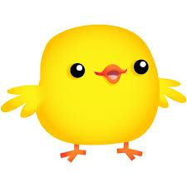
- _________ fawn
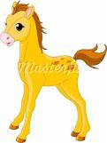
- _________ caterpillar
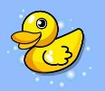
- _________ cub
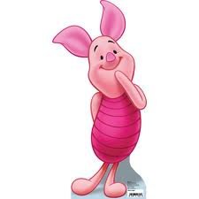
- _________ pup

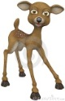
- _________ chick


- _________ piglet

9. _________ kitten

10. _________ calf

